On phonology of East Caucasian languages

G. Moroz

## Introduction

There are many studies dedicated to the phonology of the indigenous languages of the Caucasus, including (Catford 1977; Job and Smeets 1994; Smeets 1994; Alekseev et al. 2001; Hewitt 2004; Grawunder 2017; Beguš 2021; Boris 2021a, 2021b; Koryakov and Maisak Fort), and (A. E. Kibrik and Kodzasov 1990) on the East Caucasian languages in particular. There are also many studies on the historical-comparative phonetics of these languages, such as (Бокарев 1960, 1981; Гудава 1964; Имнайшвили 1977; Акиев 1977; Гигинейшвили 1977; Талибов 1980; Nikolayev and Starostin 1994; Nichols 1994; Ardoteli 2009; Мудрак 2019, 2020) and many others. Since the amount of grammatical descriptions for particular idioms is increasing, we currently have a lot more information about the phonological inventories represented in specific villages, so we do not need to extrapolate our knowledge of standard languages onto all villages where the language is spoken. Even though we have a lot of material on different East Caucasian languages, in order to be able to compare them we still need a unified description of those inventories. In order to solve this task, I compiled a database of phoneme inventories of East Caucasian and neighboring languages that can be accessed and downloaded [here](https://raw.githubusercontent.com/agricolamz/new_caucasian_phonology_dataset/master/database.csv). #change url

On average, East Caucasian languages (as well as other indigenous languages of the Caucasus) have more consonants and vowels than other languages of the world. The main reasons for this are the following:

* the presence **ejective consonants** (with the exception of Udi);
* the presence of **uvular consonants**;
* the presence of **lateral obstruents** in Andic and Tsezic languages;
* widespread **labialization**, gemination and fortis/lenis distinction across Dagestan;
* common triangle vowel systems (*i*, *e*, *a*, *o*, *u*) are complicated with **nasalization** (mostly in Andic and some Tsezic languages), **long vowels** (Nakh, Andic and Tsezic), **pharyngealisation** and **umlaut vowels** (in languages spoken in the south, possibly due to Azerbaijani influence).

## Inventory size

The map below shows the size of the phoneme inventories in languages of the eastern Caucasus:

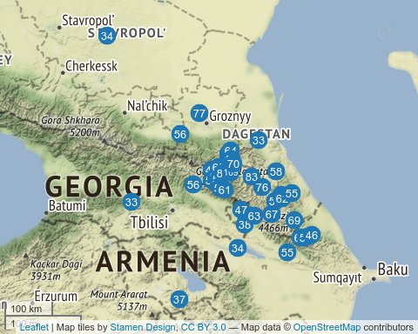

As we can see, the inventory size of the languages in our dataset range from 33 (Georgian and Kumyk) to 109 (Northern Akvakh). We can compare the obtained numbers with the PHOIBLE database (Moran, McCloy, and Wright 2014), which contains phoneme inventories of the languages of the world[1]:

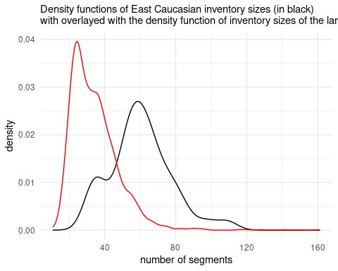

As demonstrated on the plot, East Caucasian languages in general have big segment inventories (with mean, median and mode near 60 segments) compared to languages of the rest of the world. A small peak around 40 can be explained by the presence of non-indigenous languages in our dataset. Further we will see that overall large inventories are mostly caused by large consonant inventories, although vowels and diphthongs also play a significant role.

### Consonant inventory size

We can compare the consonant inventories in the same way we compared the whole phoneme inventories earlier:

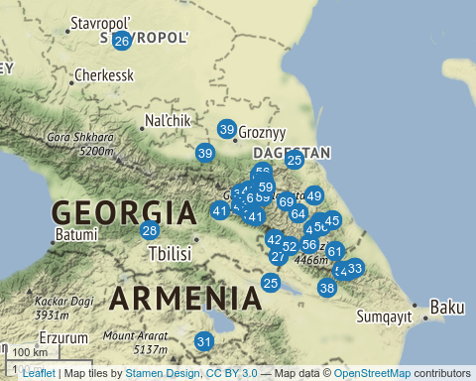

As we can see, the inventory size differs from 25 (Azerbaijani) to 89 (Northern Akvakh). We can compare the obtained numbers with the PHOIBLE database (Moran, McCloy, and Wright 2014):

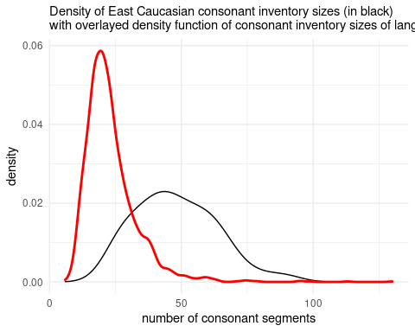

As demonstrated on the plot, the majority of languages from PHOIBLE have less consonants than East Caucasian languages. This result is caused by different subsystems of East Caucasian languages like ejectives, labialized consonants, uvulars and post uvulars. More or less the same phonological profile can be found in other indigenous language families of the Caucasus — among the West Caucasian languages, for example, we find Ubykh (Fenwick 2011: 16–17), which has one of the largest consonant inventories in the world.

### Vowel inventory size

We can do the same comparison for the vowel inventories:

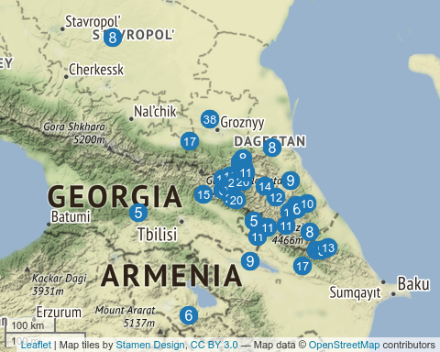

The vowel inventory size ranges from 5 (Avar) to 38 (Chechen). Again we can compare the obtained numbers with the PHOIBLE database (Moran, McCloy, and Wright 2014):

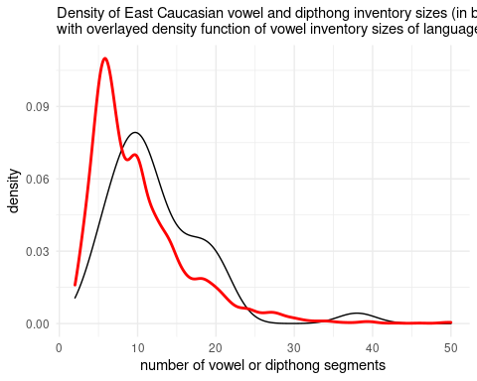 As demonstrated in the plot, the vowel/diphthong inventory sizes of East Caucasian languages are slightly bigger than the average of the languages of the world. As expected, the PHOIBLE data reveal an average vowel/diphthong inventory size of around 5, while the East Caucasian dataset shows a mean, median and mode around 10 vowels/diphthongs. Diphthongs are present only in Nakh languages and in Hinuq (Forker 2013). However, it is worth mentioning that the distinction between diphthongs and combinations of vowels and semivowels like *j* and *w* is not clear in East Caucasian languages. There is a tendency to have closing diphthongs or combinations of a vowel and a semivowel at the end of the syllable (like *ai*/*aj*, *eu*/*ew*) and opening diphthongs or combinations of a vowel and a semivowel at the beginning of the syllable (like *ia*/*ja*, *ue*/*we*). As far as I am aware, there is no phonological difference between diphthongs and combinations of vowels and semivowels in any East Caucasian language. I can stipulate that scholars of Nakh languages tend to describe those units as diphthongs while scholars of Daghestanian languages tend to describe them as combinations of a vowel and a semivowel.

## Contrasts in voiceless obstruents

A notable feature of all indigenous languages of the Caucasus is the presence of ejective consonants that are usually present in most of the possible places of articulation (see the chapter on ejective pʼ). They are not restricted to obstruents but also include affricates (and sometimes fricatives, see the chapter on ejective fricatives). This feature is so widespread that other languages of the Caucasus like the Qax dialect of Azerbaijani (Асланов 1974; Daniel 2021), the Kaytag dialect of Kumyk (Дмитриев 1940: 32), and Ossetic (Abaev 1964: 6) have borrowed some ejective consonants due to contact or an East Caucasian substrate. It is also worth mentioning that the East Caucasian language Udi lost all ejectives, evidently under the influence of Azerbaijani, and replaced them with non-aspirated obstruents.

Voiceless stops in all indigenous languages of the Caucasus tend to be slightly aspirated. In some languages there is an opposition of aspirated vs. non-aspirated stops (in Russian sources the term *преруптивный* is sometimes used): Udi, Lezgian, Khinalug.

The last important contrast that is present in East Caucasian languages is that of gemination/fortis: it is produced by the prolongation of the closure part and the reduction of aspiration in stops and affricates, and by the prolongation of the fricative part in fricatives. Different scholars treat them differently in different languages, so I decided to use gemination through all phonological chapters. It is important to notice that unlike West Caucasian and Kartvelian languages, some Andic languages and Avar have unique geminated ejectives (e. g. *kʼː*, *tsʼː*) that are produced by prolongation of the burst part of the consonant.

All those series (unaspirated voiceless - aspirated voiceless - geminates - ejectives - geminated ejectives) can be easily distinguished with the analysis of parts of consonants: the closure and post burst region, usually called Voice Onset Time or VOT (Catford 1977; Cho and Ladefoged 1999; Grawunder, Simpson, and Khalilov 2010; Grawunder et al., n.d.).

In order to analyze these data we decided to use two features:

* type of distinctions:

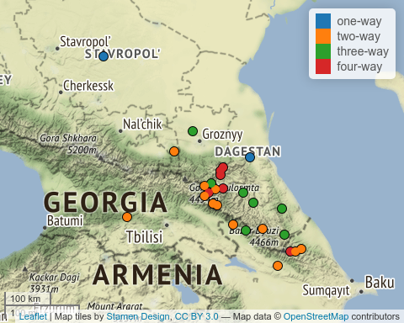

* content of distinctions denoted as a consonant symbol C:

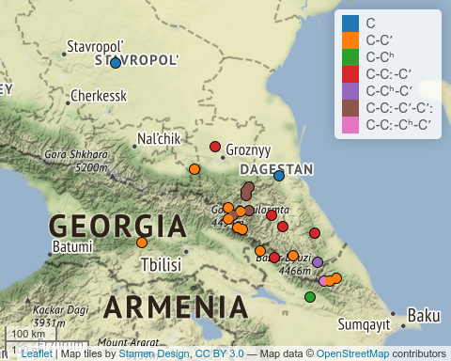

In the following table we can see the two features together:

|  |  |  |
| --- | --- | --- |
| type | content | languages |
| one-way | C | Azerbaijani, Kumyk, Nogai, Tat |
| two-way | C-Cʼ | Avar, Bagvalal, Bezhta, Budukh, Chamalal, Dargwa, Georgian, Hinuq, Hunzib, Ingush, Inkhoqwari, Khwarshi, Kryz, Rutul, Tsez, Tsova-Tush |
| two-way | C-Cʰ | Armenian, Udi |
| three-way | C-Cː-Cʼ | Agul, Archi, Chechen, Dargwa, Lak, Lezgian, Tabasaran, Tindi, Tsakhur |
| three-way | C-Cʰ-Cʼ | Khinalug, Lezgian |
| three-way | C-Cʼ-Cʼː | Chamalal |
| four-way | C-Cː-Cʼ-Cʼː | Akhvakh, Andi, Avar, Botlikh, Godoberi, Karata, Tindi |
| four-way | C-Cː-Cʰ-Cʼ | Khinalug |

Even though it is theoretically possible to have a five-way distinction, there is no such case in our dataset. A one-way contrast is present in non-East Caucasian languages (Azerbaijani, Kumyk, Nogai, Tat). The most frequent is a two-way voiceless-ejective distinction that is present in the majority of languages. The most frequent three-way distinction is the voiceless-geminated-ejective distinction. The most frequent four-way distinction is voiceless-geminated-ejective-geminated ejective, which is also reconstructed for the protolanguage (Nikolayev and Starostin 1994; Nichols 1994). This voiceless-geminated-ejective-geminated is now present exclusively in Avar and Andic languages.

It is also interesting to look at the distribution of geminates on the map:

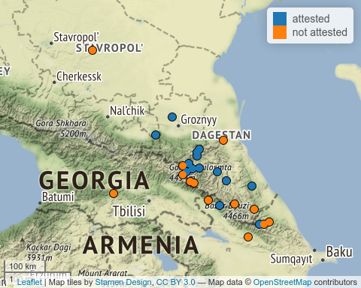

Gemination or a fortis/lenis destinction is attested across all branches of the East Caucasian family except Tsezic. It looks as though languages that border with a non-East Caucasian language lose gemination.

## Labialization

Labialization is widely attested in East Caucasian languages. However, there are some languages that have lost this feature (e.g. Budukh (Талибов 2007)). Unfortunately, sometimes scholars do not provide a full list of labialized consonants attested in a language, so it is hard to obtain a complete list. Following (Catford 1972) it is worth mentioning that there are several types of labialization:

* /w/-labialization — this kind of labialization is more or less independent of the main place of articulation. This kind of labialization is typical for velar and uvular fricatives and stops and widely attested in East Caucasian languages;
* /ɥ/-labialization — this kind of labialization is typical for pharyngeals. It looks like the tongue body is retracted (due to the pharyngeal place of articulation) and raised, which results in a /ɥ/-like sound that is not present in East Caucasian languages;
* /y/-labialization — this kind of labialization is typical only for post-alveolars found in Abkhaz and Abaza (West Caucasian), but also may be the case in Tabasaran (Кибрик et al. 1982: 7–8; A. E. Kibrik and Kodzasov 1990: 337) and Agul (A. E. Kibrik and Kodzasov 1990: 338).

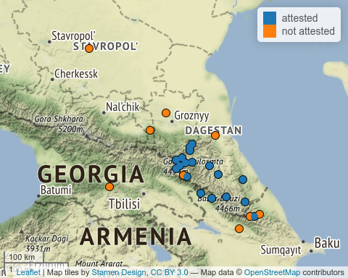

As we can see, labialization is lost in Bezhta, Udi, Budukh and Khinalug. Possibly the absence of labialized consonants in Nakh languages results from a reinterpretation by scholars of the *w* as forming part of a diphthong. Georgian probably also has labialized consonants, but those cases are analyzed as a combination of a consonant and *w*.

## Presence of laterals

Laterals are a significant feature of Avar, Andic and Tsezic languages, as well as the Lezgic language Archi. In most cases the lateral system is represented by a fricative *ɬ* and two affricates *tɬ* and *tɬ’*. Sometimes the subsystem is even more elaborate due to the presence of geminates.

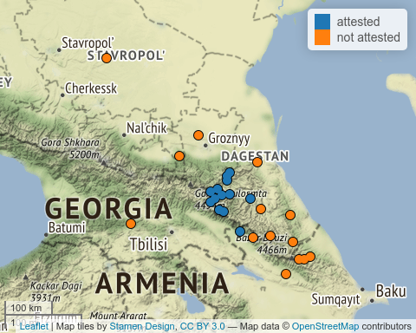

The lateral inventory can differ from 1 (Tsova-Tush, *ɬ*) to 12 (Akhvakh, *ɬ*, *tɬ*, *tɬ’*, each of which have a geminate, labialized and geminate labialized counterpart).

## Presence of long vowels

Long vowels are present in northern Dagestan, Chechnya and Ingushetia. They are not present in Avar and southern Dagestan. However, there are a few cases where they are reported as the result of some intervocalic consonant deletions.

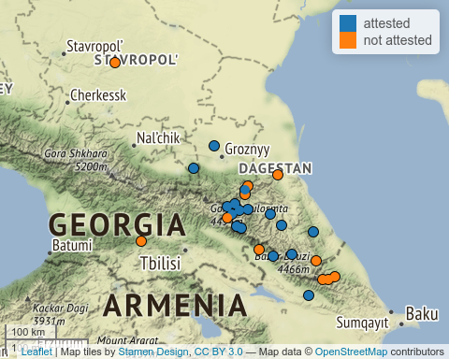

## Presence of nasal vowels

Nasalized vowels are a comon feature of Andic and Tsezic languages, hovewer some researchers report a sporadic final **n**-delition that leads to the development of nasalized vowels in other branches (e.g. Bezhta, (Талибов 2007)).

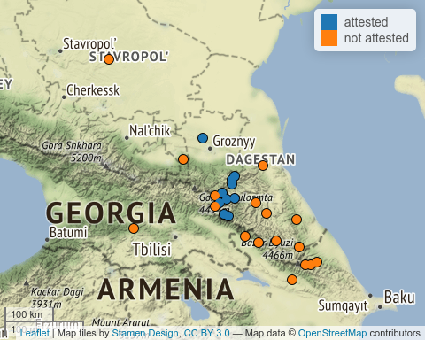

## Pharyngeals

Pharyngeals in the Caucasus are covered extensively in the literature (Catford 1983; Кодзасов 1986; Kodzasov 1987; Colarusso 2013; Arkhipov et al. 2019; Беляев 2021). Even thought there is a new model of laryngeal articulation (Esling 1996, 2005), it is hard to adjust data created within the old model to the new approach without a new acoustic study, therefor I will use the standard IPA model here, which distinguishes pharyngeals (*ħ*, *ʕ*) and epiglottals (*ʜ*, *ʢ*, *ʡ*).

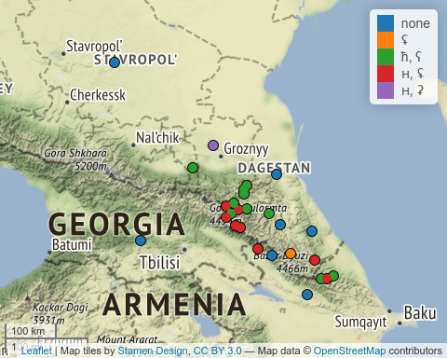

The most common scenario is one place of articulation (or none): either pharyngeal or epiglottal, with a voiced and a voiceless consonant. The rest of the systems are connected to an epiglottal stop that is merged with different subsystems. There are also rare cases with just one pharyngeal consonant: *ħ* or *ʢ*.

|  |  |
| --- | --- |
| fricative inventory | languages |
| none | Armenian, Georgian, Karata, Kumyk, Lak, Lezgian, Nogai, Tabasaran, Tsakhur, Udi |
| ʜ, ʢ | Agul, Akhvakh, Andi, Archi, Avar, Bagvalal, Bezhta, Chamalal, Dargwa, Hinuq, Hunzib, Inkhoqwari, Khinalug, Kryz, Lezgian, Tindi, Tsez |
| ħ, ʕ | Akhvakh, Andi, Archi, Bezhta, Botlikh, Budukh, Chamalal, Dargwa, Godoberi, Hunzib, Ingush, Karata, Khinalug, Khwarshi, Kryz, Tindi, Tsova-Tush |
| ħ, ʡ | Hinuq, Rutul, Tat |
| ħ, ʕ, ʡ | Avar, Dargwa |
| ʜ, ʡ, ʢ | Agul, Budukh |
| ħ | Azerbaijani, Tsez |
| ħ, ʜ, ʡ | Dargwa |
| ʜ, ʡ | Chechen |
| ʢ | Rutul |

## Presence of pharyngealized segments

Pharyngealization is a complex feature that is realized as a constriction in the pharynx or epiglottis zone. Different scholars use different strategies for describing the locus of the pharyngealization: sometimes it is analyzed as a feature of the vowel (Forker 2013), or as a consonant feature (Khalilova 2009), or it is treated as a suprasegmental feature (Aleksandr E. Kibrik 1994; Moroz 2019). Pharyngealization commonly spreads through the word, although most researchers distinguish a core pharyngealized syllable (Aleksandr E. Kibrik 1994; Талибов 2007; Moroz 2019; Беляев 2021). Some East Caucasian languages are known to have developed two different types of pharyngealization (e.g. Беляев 2021), further complicating the picture. As we can see from the map, pharyngealization is common in central and southern Dagestan among languages of the Dargwa, Lak, Tsezic and Lezgic branches.

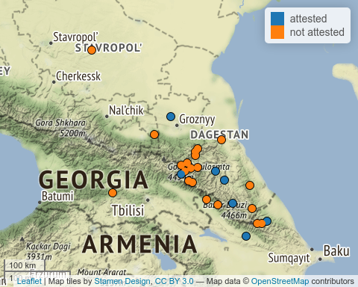

## Inventory of v-like consonants

The most common labial sound in East Caucasian languages is the bilabial **w** which is present in most languages, however in southern Daghestan the approximant become a fricative **v**. In the Dargwa village Ayalakab I witnessed the bilabial fricative realisation **β**.

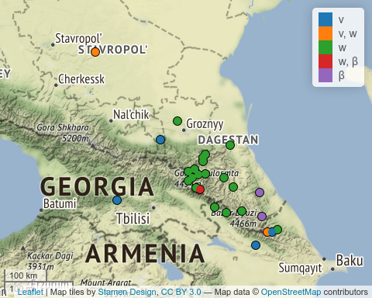

|  |  |
| --- | --- |
| fricative inventory | languages |
| w | Agul, Akhvakh, Andi, Archi, Avar, Bagvalal, Bezhta, Botlikh, Budukh, Chamalal, Chechen, Dargwa, Godoberi, Hinuq, Hunzib, Inkhoqwari, Karata, Khwarshi, Kumyk, Lak, Lezgian, Rutul, Tabasaran, Tindi, Tsakhur, Tsez |
| v | Azerbaijani, Georgian, Ingush, Khinalug, Kryz, Rutul, Tat, Tsova-Tush, Udi |
| v, w | Armenian, Budukh, Khinalug, Nogai |
| w, β | Dargwa, Hunzib |
| β | Lezgian, Tabasaran |

## Presence of umlaut vowels

Umlaut vowels are present in southern Dagestan and in Nakh languages. I can speculatively propose that they historically developed from pharyngealization, but this hypothesis needs to be accurately checked with shared lexicon.

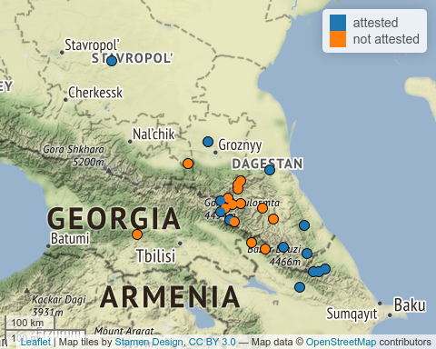

## Presence of velar fricatives

The presence of velar fricatives is a complicated feature, since many Russian scholars tend to merge the voiced velar fricative *ɣ* and voiced velar stop *ɡ*. Sometimes the voiced velar fricative is mixed (or positionally distributed) with the voiced uvular fricative *ʁ*, and, as a result, scholars provide a merged velar-uvular place of articulation or choose one of them.

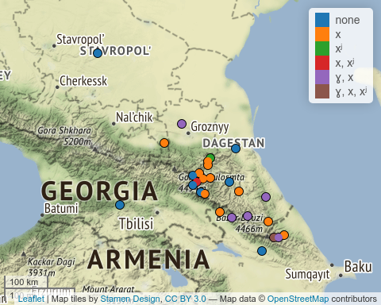

The table below shows the inventories of velar fricatives. As we can see from the table as well as the map, the most common inventory is just *x*. There are 11 languages that lack velar fricatives, including all non-East Caucasian languages (except Azerbaijani). Eight languages have both voiced and voiceless fricatives. Other systems are rare.

|  |  |
| --- | --- |
| fricative inventory | languages |
| none | Archi, Armenian, Bezhta, Georgian, Hinuq, Inkhoqwari, Kumyk, Nogai, Tat, Tsez, Udi |
| x | Agul, Akhvakh, Andi, Avar, Bagvalal, Botlikh, Budukh, Chamalal, Dargwa, Godoberi, Hunzib, Ingush, Khwarshi, Lak, Lezgian |
| xʲ | Andi, Azerbaijani |
| x, xʲ | Agul, Karata, Tindi, Tsakhur |
| ɣ, x | Budukh, Chechen, Dargwa, Kryz, Rutul, Tabasaran, Tsakhur, Tsova-Tush |
| ɣ, x, xʲ | Karata, Khinalug |
| ɣ, ɣʲ, x, xʲ | Khinalug |

## Presence of palatalized consonants

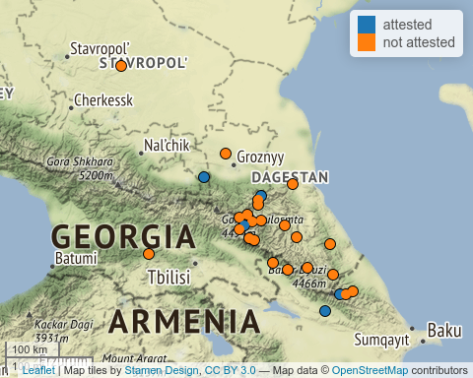

## Presence of uvular voiced stop

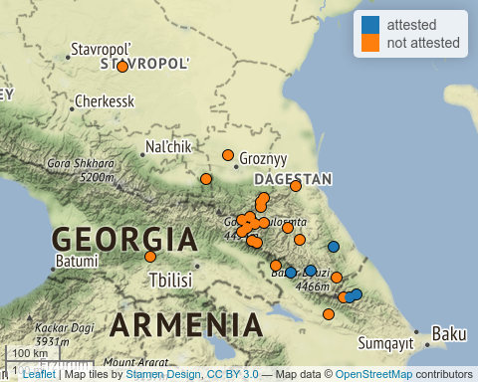

## Presence of ejective pʼ

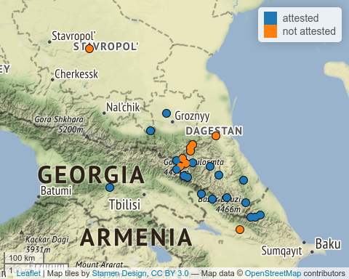

Abaev, V. I. 1964. *A Grammatical Sketch of Ossetic*. Bloomington: Indiana Univesrity Press.

Alekseev, M. E., S. A. Starostin, G. A. Klimov, and Ya. G. Testelets. 2001. *Yazyki Mira. Kavkazskiye Yaziki*. Academia.

Ardoteli, Nodar. 2009. *Xunjuri-Andiuri-Didouri Enat’a Istoriul-šedarebit’i p’onetika*. Gamomc’emloba Universali.

Arkhipov, A., M. Daniel, O. Belyaev, G. Moroz, and J. H. Esling. 2019. “A Reinterpretation of Lower-Vocal-Tract Articulations in Caucasian Languages.” In *Proceedings of the 19th International Congress of the Phonetic Sciences*, 5–9.

Beguš, Gašper. 2021. “Segmental Phonetics and Phonology.” In *The Oxford Handbook of Languages of the Caucasus*, edited by Maria Polinsky, 1–40. Language Science Press.

Boris, Lena. 2021a. “Tone and Intonation in Languages of the Caucasus.” In *The Oxford Handbook of Languages of the Caucasus*, edited by Maria Polinsky, 1–30. Oxford University Press.

———. 2021b. “Word Stress in the Languages of the Caucasus.” In *The Oxford Handbook of Languages of the Caucasus*, edited by Maria Polinsky, 1–30. Language Science Press.

Catford, J. C. 1972. “Labialisation in Causasian Languages, with Special Reference to Abkhaz.” In *Proceedings of the Seventh International Congress of Phonetic Sciences/Actes Du Septième Congrès International Des Sciences Phonétiques*, 679–82. De Gruyter Mouton.

———. 1977. *Fundamental Problems in Phonetics*. Edinburgh: Edinburgh University Press.

———. 1983. “Pharyngeal and Laryngeal Sounds in Caucasian Languages.” In *Vocal Fold Physiology: Contemporary Research and Clinical Issues*, 344–50. San Diego, CA: College Hill Press.

Cho, T., and P. Ladefoged. 1999. “Variation and Universals in VOT: Evidence from 18 Languages.” *Journal of Phonetics* 27: 207–29.

Colarusso, J. 2013. “The Typology of Gutturals.” In *Base Articulatoire Arrière: Backing and Backness*, edited by Jean Léo Léonard and Samia Naïm, 93–109. Munich: LINCOM Europa.

Daniel, Michael. 2021. “Ejectives in the Azerbaijani of Ilisu.”

Esling, J. H. 1996. “Pharyngeal Consonants and the Aryepiglottic Sphincter.” *Journal of the International Phonetic Association* 26 (2): 65–88.

———. 2005. “There Are No Back Vowels: The Larygeal Articulator Model.” *Canadian Journal of Linguistics/Revue Canadienne de Linguistique* 50 (1-4): 13–44.

Fenwick, R. S. H. 2011. *A Grammar of Ubykh*. Lincom Europa.

Forker, D. 2013. *A Grammar of Hinuq*. De Gruyter Mouton.

Grawunder, S. 2017. “The Caucasus.” In *The Oxford Handbook of Languages of the Caucasus*, edited by R. Hickey, 356–95. Cambridge University Press.

Grawunder, S., G. Moroz, V. Zhigulskaya, and M. Daniel. n.d. “VOT in Two East Caucasian Languages.”

Grawunder, S., A. Simpson, and M. Khalilov. 2010. “Phonetic Characteristics of Ejectives - Samples from Caucasian Languages.” In *Turbulent Sounds - an Interdisciplinary Guide, Number 21 in Interface Explorations*, edited by Jean Léo Léonard and Samia Naïm, 356–95. Berlin: De Gruyter Mouton.

Hewitt, George. 2004. *Introduction to the Study of the Languages of the Caucasus*. Lincom.

Job, D. M., and R. Smeets, eds. 1994. *The Indigenous Languages of the Caucasus*. Vol. 3. Caravan Books.

Khalilova, Zaira. 2009. “A Grammar of Khwarshi.” PhD thesis, Leiden University.

Kibrik, A. E., and S. V. Kodzasov. 1990. *Sopostavitelnoye Izucheniye Dagestanskix Yazykov: Imya. Fonetika*. Vol. 2. Moskovskij Gosudarstvennyj Universitet.

Kibrik, Aleksandr E. 1994. “Archi.” In *The Indigenous Languages of the Caucasus. Vol. 4: The Northeast Caucasian Languages. Part 2*, edited by Rieks Smeets, 297–365. Delmar, NY: Caravan Press.

Kodzasov, S. V. 1987. “Pharyngeal Features in the Daghestan Languages.” In *Proceedings of the XIth International Congress of Phonetic Sciences*, 2:142–44.

Koryakov, Yu., and T. Maisak, eds. Fort. *Handbook of Caucasian Languages*. Vol. 2. Berlin/New York: De Gruyter Mouton.

Moran, Steven, Daniel McCloy, and Richard Wright, eds. 2014. *PHOIBLE Online*. Leipzig: Max Planck Institute for Evolutionary Anthropology. <http://phoible.org/>.

Moroz, George. 2019. “Phonology of Mehweb.” In *The Mehweb Language: Essays on Phonology, Morphology and Syntax*, edited by Michael Daniel, Nina Dobrushina, and Dmitry Ganenkov, 17–39. Language Science Press.

Nichols, Johanna. 1994. “The Nakh-Daghestanian Consonant Correspondences.” In *Current Trends in Caucasian, East European, and Inner Asian Linguistics : Papers in Honor of Howard i. Aronson*, edited by Dee Ann Holisky and Kevin Tuite, 207–65. John Benjamins Publication Company.

Nikolayev, S. L., and S. A. Starostin. 1994. *A North Caucasian Etymological Dictionary*. Asterisk Press.

Smeets, R., ed. 1994. *The Indigenous Languages of the Caucasus*. Vol. 4. Caravan Books.

Акиев, А. Ш. 1977. “Историко-сравнительная фонетика даргинского и лакского языков: Система консонантизма.” *Дагучпедгиз*.

Асланов, А. М. 1974. “Иберийско-кавказские абруптивы в закатальско-кахских говорах азербайджанского языка.” *Ежегодник иберийско-кавказского языкознания* 1: 224–28.

Беляев, О. И. 2021. “Два типа фарингализации в ширинском даргинском: Предварительные наблюдения.” In *ДУРХЪАСИ ХАЗНА*, edited by Т. А. Майсак, Н. Р. Сумбатова, and Я. Г. Тестелец, 18–29.

Бокарев, Евгений Алексеевич. 1960. *Основные вопросы исторической фонетики дагестанских языков*. Издательство восточной литературы.

———. 1981. *Сравнительно-историческая фонетика восточнокавказских языков*. Наука.

Гигинейшвили, Б. К. 1977. “Сравнительная фонетика дагестанских языков.” *Тбилиси: Издательство Тбилисского университета*.

Гудава, Того Евстафьевич. 1964. *Консонантизм андийских языков: Историко-сравнительный анализ*. Изд-во Академии наук Грузинской ССР.

Дмитриев, Н. К. 1940. *Грамматика кумыкского языка*. АН СССР.

Имнайшвили, Д. С. 1977. *Историко-сравнительный анализ фонетики нахских языков*. Мецниереба.

Кибрик, Бергельсон, А. Е., КК Богатырев, ОЮ Богуславская, Анна А Зализняк, СВ and Кодзасов, ИА Муравьева, ВА Плунгян, and ЕВ Рахилина. 1982. “Табасаранские этюды.”

Кодзасов, С. В. 1986. “Фаринго-ларингальное сужение в дагестанских языках.” In *Актуальные проблемы дагестанско-нахского языкознания*, 344–50. Махачкала: Даг. фил. АН СССР.

Мудрак, Олег Алексеевич. 2019. “Аварские основы.”

———. 2020. “Андийские основы.”

Талибов, Б. Б. 1980. *Сравнительная фонетика лезгинских языков*. Наука.

———. 2007. *Будухский язык*. Academia.

1. When performing such a comparison of our dataset and the one provided by PHOIBLE, the question arises whether we need to exclude East Caucasian and other languages of the Caucasus from the PHOIBLE subsample that we use. In this text we decided to exclude them for the sake of comparability. Not excluding them slightly changed the shape of the density plot shown below, but the change was extremely small. Keep in mind that neither of the samples are balanced, so that they are not ideal for comparison: different language families are overrepresented in both samples, and the sizes of the datasets are different (PHOIBLE’s 2169 languages vs our dataset of 50 idioms) etc.